READING: Birth of the Space Shuttle

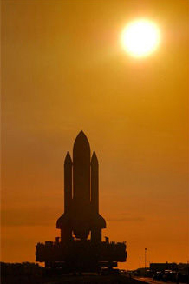
The concept of using a reusable space vehicle, such as the Space Shuttle, was first introduced in 1966. At this time, NASA determined that there were not enough funds in the budget to actively pursue an alternative space vehicle to the Saturn Rocket. It was not until three years later that the U.S. Government asked NASA, “After Apollo, what’s next?” This caused NASA to begin pursuing the design of a fully reusable launch vehicle, which NASA called an “integral launch and reentry vehicle.” It was believed that the creation of a reusable vehicle would lower the overall cost for a launch, and it would allow for quicker turnaround on the vehicle so it could be launched again.

In 1971, a committee submitted to NASA officials a design for a fully reusable launch vehicle. The drawback to this initial design was the overall cost of the new vehicle, roughly $10.5 billion dollars. Knowing that Congress most likely would not support such a costly program, NASA officials tried to make alterations to the “totally” reusable launch vehicle to cut the cost. As a result, the team charged with the task of designing this new space vehicle developed a design similar to that of our current space shuttles.

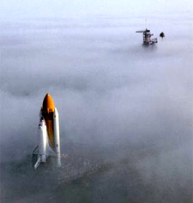
This new design called for a reusable orbiter, reusable rocket boosters, and an expendable external fuel tank. These modifications to the original design cut the cost of the project in half to roughly $5 billion dollars. What made this new design so extraordinary was that the orbiter would be launched like a rocket, maneuver in orbit like a spacecraft, and be able to land like an airplane.

In order to launch the orbiter into space, the main engines of the orbiter and the SRBs would supply all the thrust needed to get the vehicle into orbit. The solid fuel of the SRBs would last a couple of minutes and then be jettisoned when all of the fuel was consumed. Once separated from the orbiter, parachutes would be deployed, and the SRBs would fall safely into the ocean where they would be picked up by boats and brought back to Kennedy Space Center (KSC). When the orbiter had finished its mission, it would glide back to Earth and land like an airplane. Both the orbiter and SRB could then be processed and reused again. Conversely, the ET would stay attached to the orbiter for several minutes longer than the SRBs and supply liquid fuel to the main engines. When its fuel was completely consumed, it would be jettisoned and never used again.

NASA officials pitched the new design to Congress. Congress approved it and allocated government funds to financially support this new project labeled the Space Transportation System (STS), or more affectionately called the “Shuttle Program.” A team of developers were brought together to finalize the design of the new reusable vehicle; this was a two-year process that ran from 1972 to 1974. It was in 1974 that the final design for this new vehicle was submitted back to NASA officials. It was at this time that the new Space Shuttle program was officially born.

In 1976, the first orbiter in the shuttle fleet rolled out of the assembly plant. Enterprise became the main test orbiter for the shuttle program and would be put to the test over the next year to ensure that all the main systems of the orbiter, with the exception of the main engines, would function properly. It was not until the orbiter Columbia reached Kennedy Space Center in 1979 that all shuttle systems, including the three main engines, would undergo integration tests. Finally, just two months prior to its first launch, a flight readiness firing test was conducted on Columbia’s main engines.

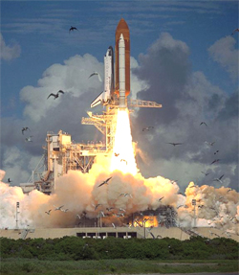
On April 12, 1981, just after 7:00 am, the Space Shuttle Columbia STS 1 launched, carrying Commander John Young and Pilot Robert Crippen for a two day orbiting trip in space. During this time, Young and Crippen ran a series of tests on the systems of the orbiter to ensure that everything was working properly. To this point, the performance of the three key components of this new space vehicle – the reusable orbiter (a delta-winged craft with three main engines, large crew compartments, and a 15’ X 60’ cargo bay), two reusable SRBs, and an expendable external tank (ET) – was as hoped. Information collected by Young and Crippen over the two-day mission provided NASA with much needed data to ensure and improve the Orbiter’s systems. Columbia successfully returned to Earth and was processed to be launched again. Within the next two years, Columbia was successfully launched another four times, making NASA’s dream of having a reusable launch vehicle a reality.

